**ABS / HLS STREAMING**

ABS (Adaptive Bitrate Streaming) and HLS (HTTP Live Streaming) are technologies used for delivering video content over the internet.

ABS(adaptive bitrate streaming): Adaptive Bitrate Streaming is a technique for streaming multimedia over the internet that adjusts the quality of the video or audio stream in real time based on the user's network conditions and device capabilities.

It is a method for improving streaming over HTTP network.

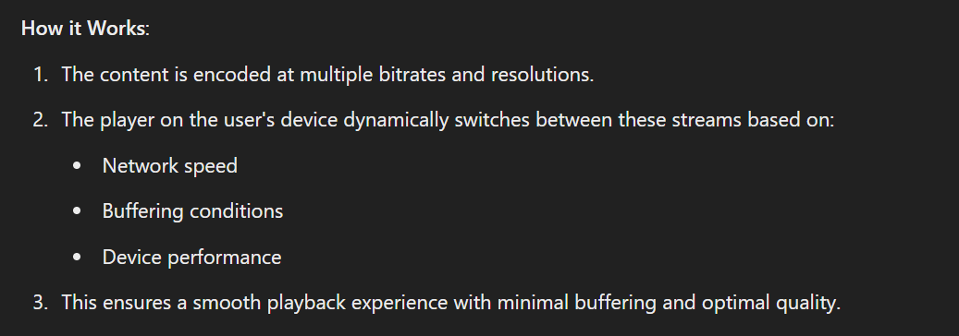

Benefits:

* Reduces buffering during slow network
* Provides a seamless viewing experience

HLS (HTTP Live Streaming): HLS is a protocol developed by Apple for streaming media over the internet. It's based on HTTP and supports adaptive bitrate streaming.

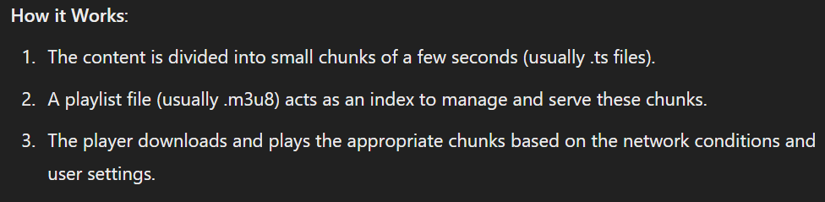

HLS

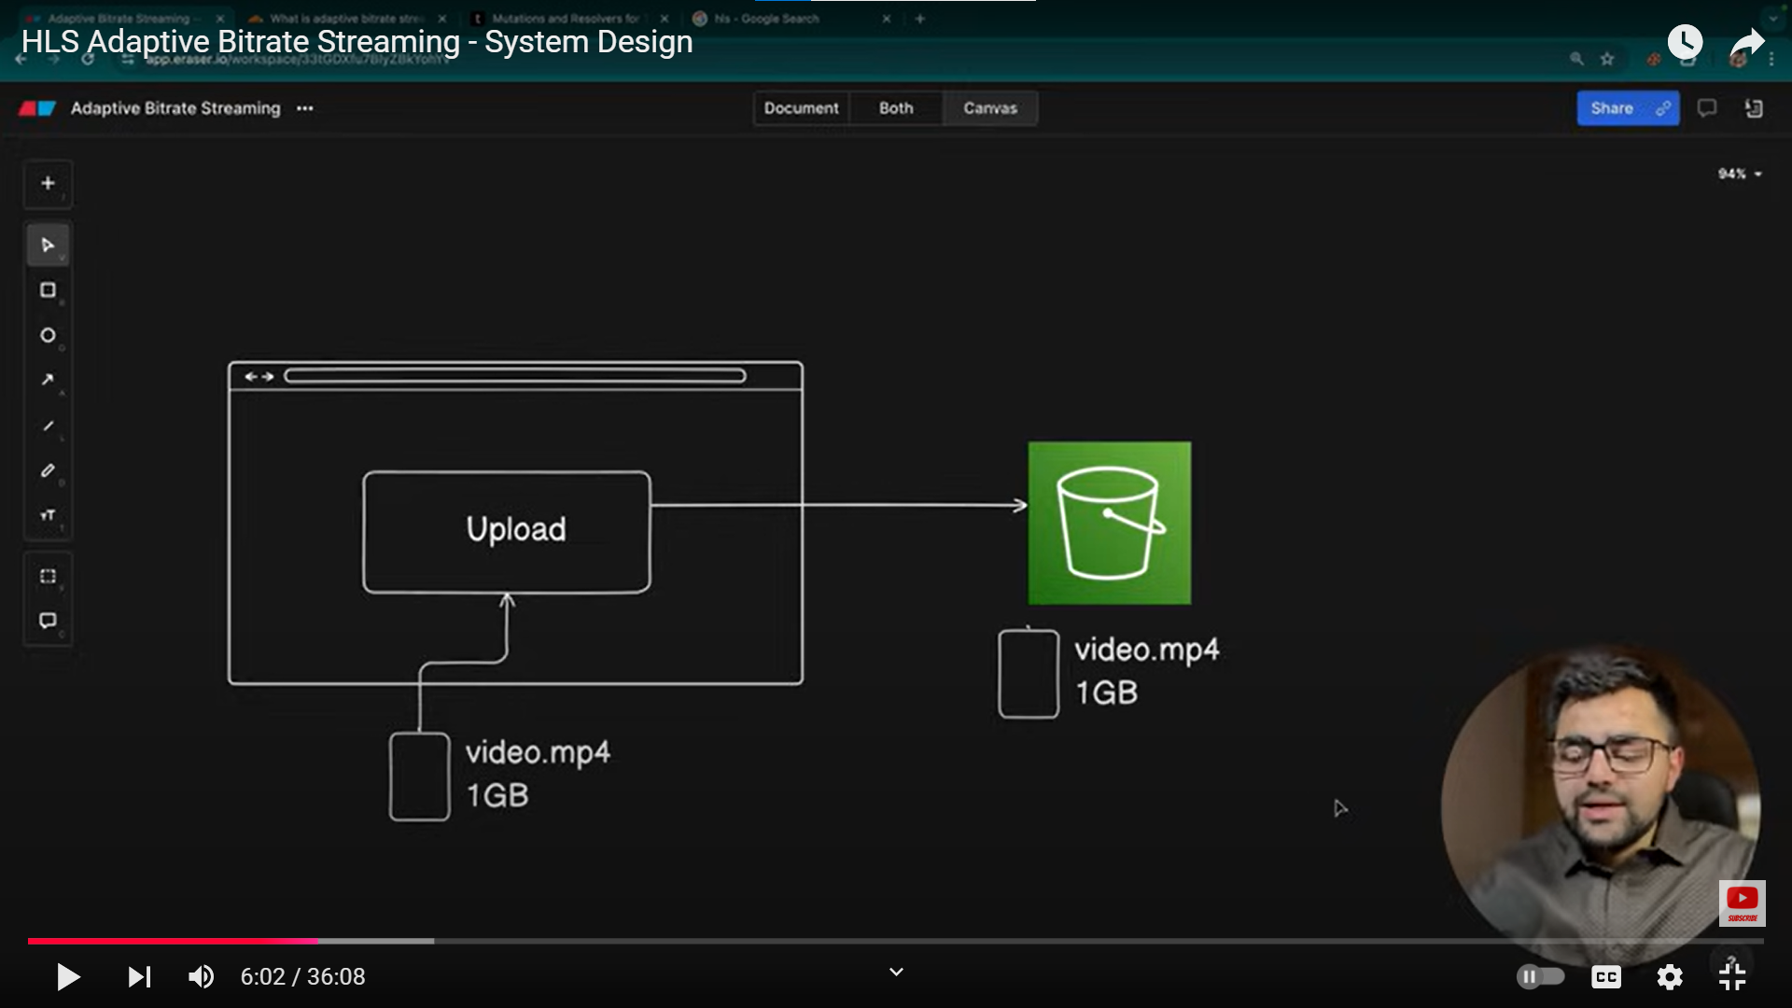

User uploaded video on amazon s3 services

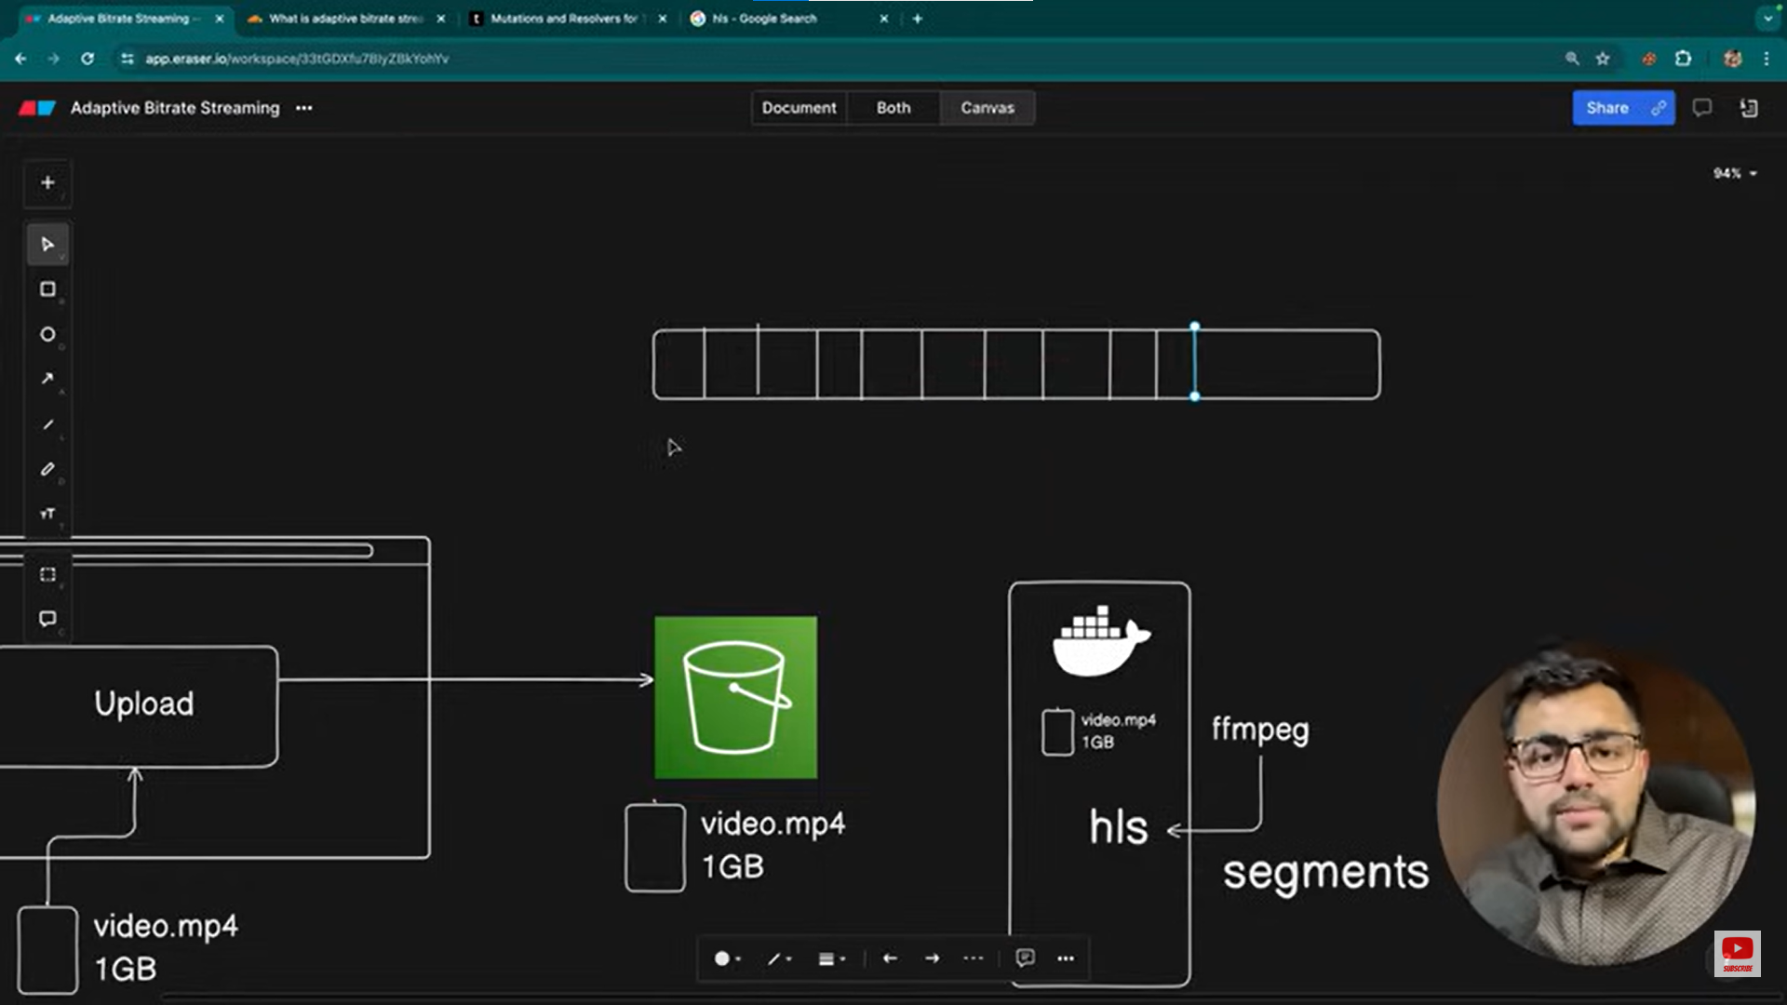

Hls divide the video in segment

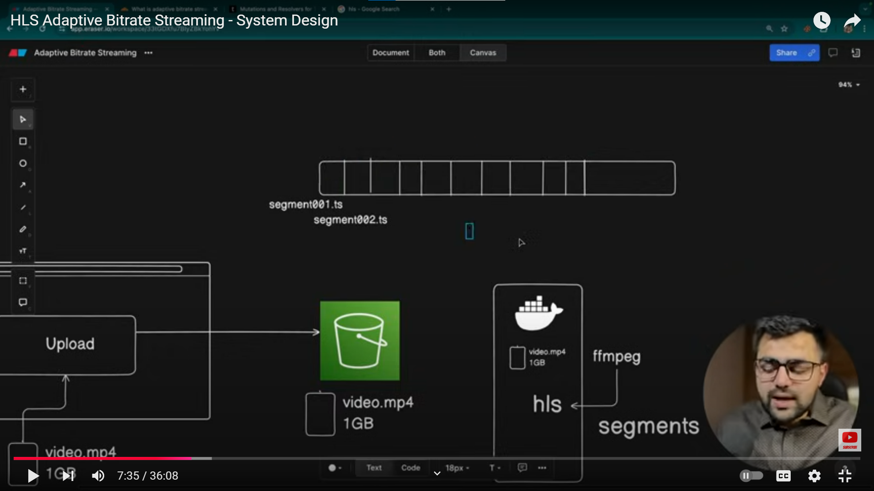

(segment001.ts) is the name of chunk provided by hls (.ts is not typescript)

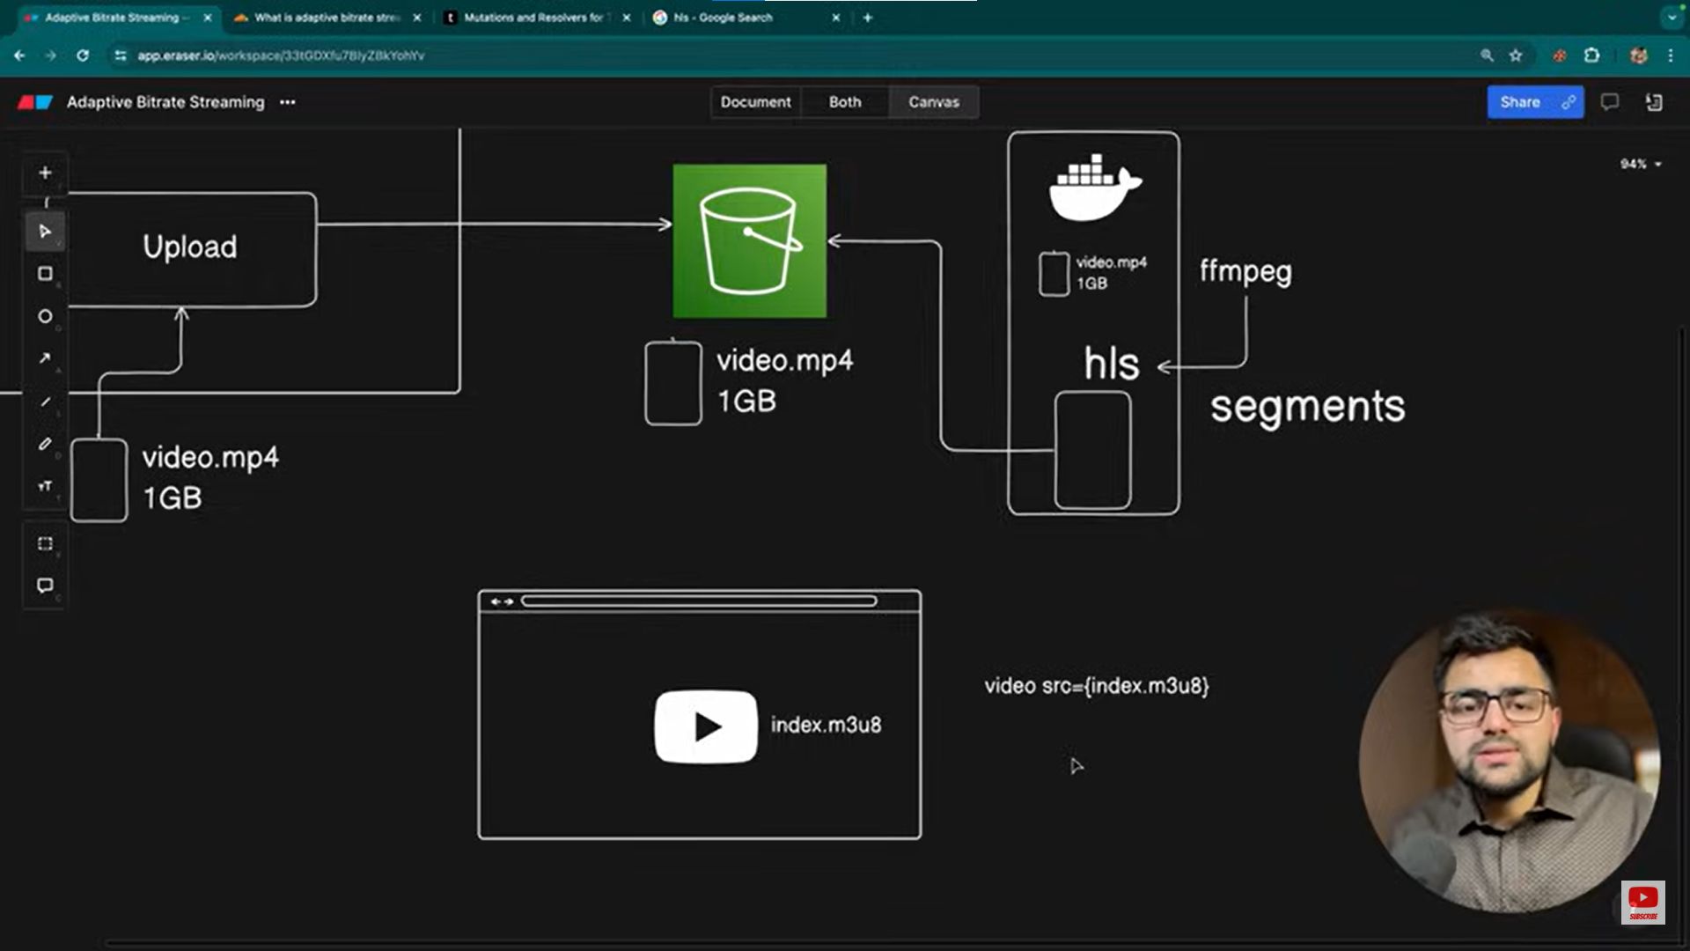

After all segments are made. It will create index.m3u8 file which contains all the information of segements (video.js) tools are used to read such files.

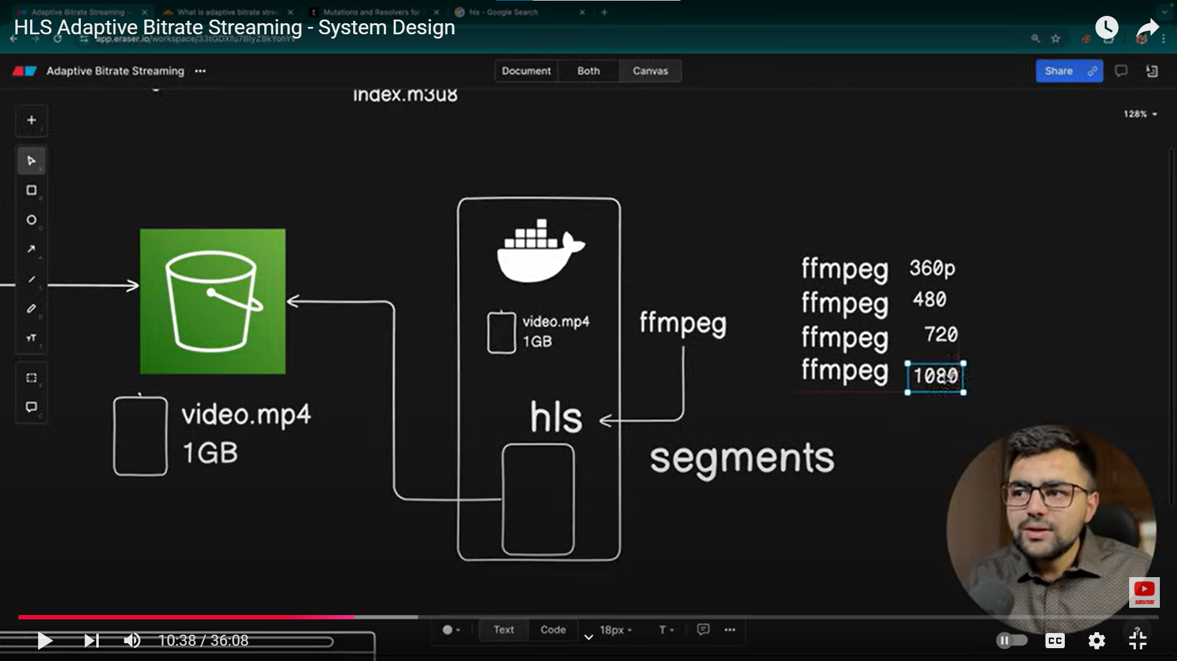

We need to run Ffmpeg according to our requirement

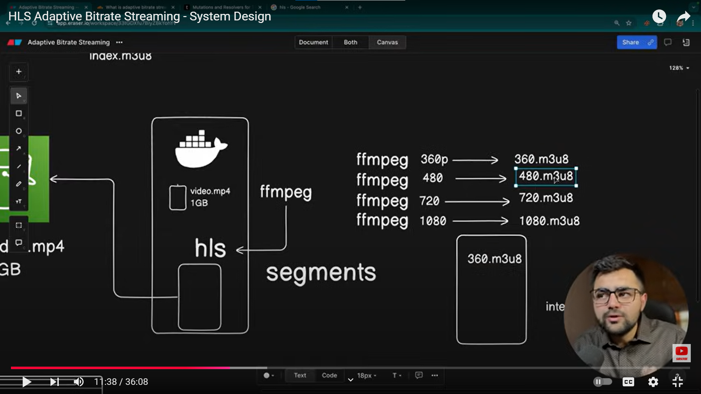

In master.js file we clarify that if internet speed is low use 360.m3u8

